Assignment #4 MLR by Joshua Troup

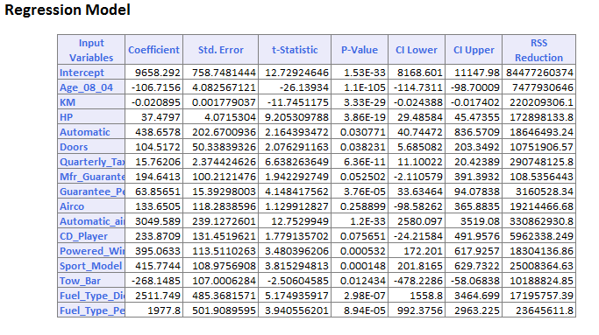

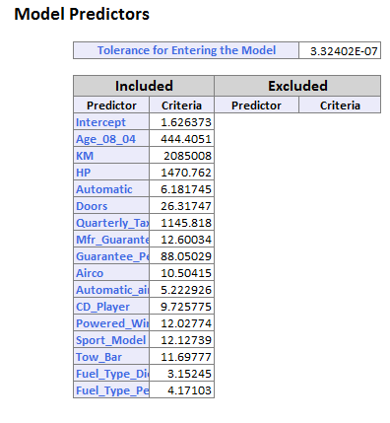

1. The top 3 predicator variables for determining used car price are Age, KM, and HP.

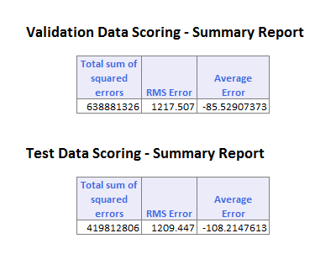

1. The difference between the test data and validation is very close as shown above. The average error is -$85
2. MAPE =123.45%